Laxmi Charitable Trust’s
Sheth L.U.J College of Arts & Sir M.V. College of Science and Commerce
Department of Information Technology (B.Sc.I.T Semester V)
MERN STACK
Practical – IV
Roll No.: T022 | Name: Pratik Mishra
Class: TYIT | Batch:1
Date of Assignment:15-7-26 | Date/Time of Submission:15-7-26

4.React Components, Props, and State
b. Pass data between components using props.
Code :
App.jsx
import Header from "./components/Header";
import Footer from "./components/Footer";
import HotelCard from "./components/HotelCard";
import "./App.css";

function App() {
return (
<div className="container">
<Header />
<HotelCard
resturant = "Domino's Pizza"
food = "Pizza, Pasta, Beverages"
price = {1599}
rating = {4.5}
discount = {20}/>
<HotelCard
resturant = "McDonald's"
food = "Burgers, Fries, Beverages"
price = {1699}
rating = {4.5}
discount = {20}/>
<HotelCard
resturant = "Pizza Hut"
food = "Pizza, Pasta, Beverages"
price = {599}
rating = {4.5}
discount = {20}/>
<HotelCard
resturant = "Chicken Hut"
food = "chicken Pizza, chicken hande Pasta, Beverages"
price = {1099}
rating = {4.5}
discount = {20}/>
<Footer />
</div>
);
}

export default App;

Header.jsx
function Header() {
return (
<div>
<h1>Online Food Delivery Dashboard</h1>
<h3>Pratik Mishra</h3>
<hr />
</div>
);
}

export default Header;

HotelCard.jsx
function HotelCard(props) {
const discount = (props.price * props.discount) / 100;
const finalPrice = props.price - discount;

return(
<div>
<h2>{props.restaurant}</h2>
<p>Food Item : {props.food}</p>
<p>Original Price : ₹{props.price}</p>
<p>Discount : {props.discount}%</p>
<p>Final Price : ₹{finalPrice}</p>
<p>Rating : {props.rating}</p>
</div>
);
}

export default HotelCard;

Footer.jsx
function Footer() {
return (
<div>
<p>© 2026 Online Food Delivery App</p>
</div>
);
}

export default Footer;
Output:
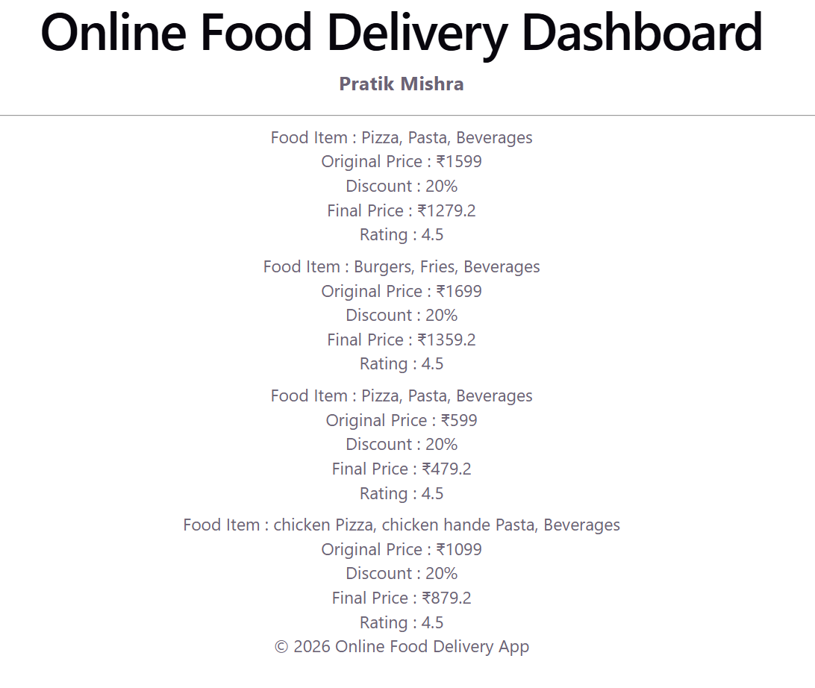
c. Use the useState hook to manage and update data.
Code-:
App.jsx
import { useState } from "react";

function Apps() {
const [count, setCount] = useState(0);

return (
<div>
<h1>Button Click Counter</h1>
<hr />
<h2>User clicks: {count} times</h2>
<h3>Pratik </h3>
<button onClick={() => setCount(count + 1)}>Click Me</button>
</div>
);
}

Output-:
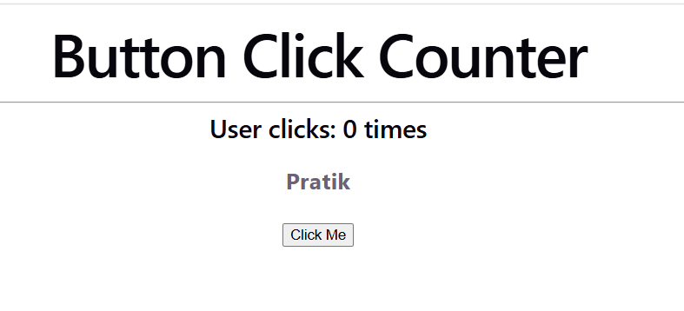
d. Create a form component to accept user input and display it
dynamically.
App jsx-:
import StudentForm from "./components/StudentForm"
function Apps() {

return(
<div>
<StudentForm> </StudentForm>
</div>
);
}
export default Apps;
Student form jsx-:
import { useState } from "react";

function StudentRegisterForm() {
const [name, setName] = useState("");
const [email, setEmail] = useState("");
const [phone, setPhone] = useState("");
const [CGPA, setCgpa] = useState("");

return (
<div>
<h1>Student Registration Form</h1>
<hr/>
<label>Name:</label>
<input type="text" placeholder="Enter Name" value={name} onChange={(e) => setName(e.target.value)} />
<br/>
<label>Email:</label>
<input type="email" placeholder="Enter Email" value={email} onChange={(e) => setEmail(e.target.value)} />
<br/>
<label>Phone Number:</label>
<input type="text" placeholder="Enter Phone Number" value={phone} onChange={(e) => setPhone(e.target.value)} />
<br/>
<label>CGPA:</label>
<input type="text" placeholder="Enter CGPA" value={CGPA} onChange={(e) => setCgpa(e.target.value)} />
<br/>
<button type="submit" onClick={() => {}}>Submit</button>
<hr/>
<h2>Student details</h2>
<p>Name: {name}</p>
<p>Email: {email}</p>
<p>Phone Number: {phone}</p>
<p>CGPA: {CGPA}</p>
</div>

);
}

export default StudentRegisterForm;
output-:
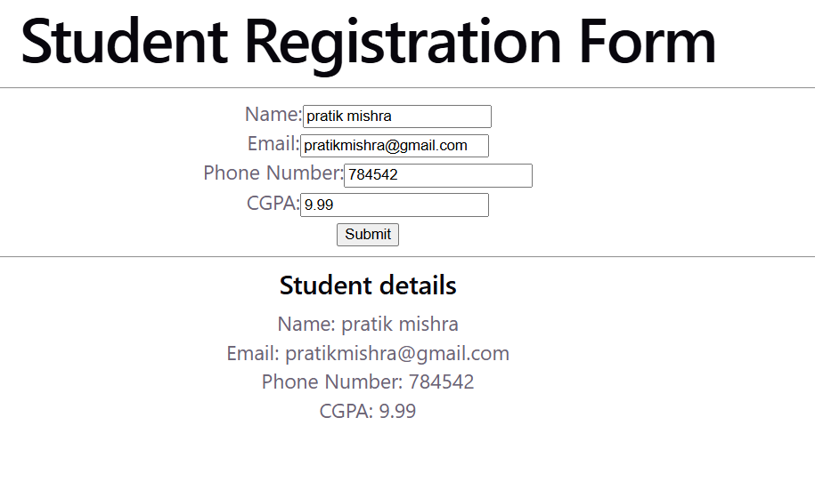
e. Display a list of items stored in the state using map().
Code-:
App.jsx
import CompanyList from './components/CompanyList';
import './App.css';

function App() {
return (
<div className="App">
<h1>Company List</h1>
<CompanyList />
</div>
);
}

export default App;

CompanyList.jsx
import {useState} from 'react';

function CompanyList() {
const [companies] = useState([
"TCS",
"Infosys",
"Wipro",
"HCL",
"Tech Mahindra"
]);

return (
<div>
<h2>Placement Companies</h2>
<h3>Neeraj</h3>
<hr/>
<ol>
{companies.map((company, index) => (
<li key={index}>{company}</li>
))}
</ol>
</div>
);
}

export default CompanyList;
output-:
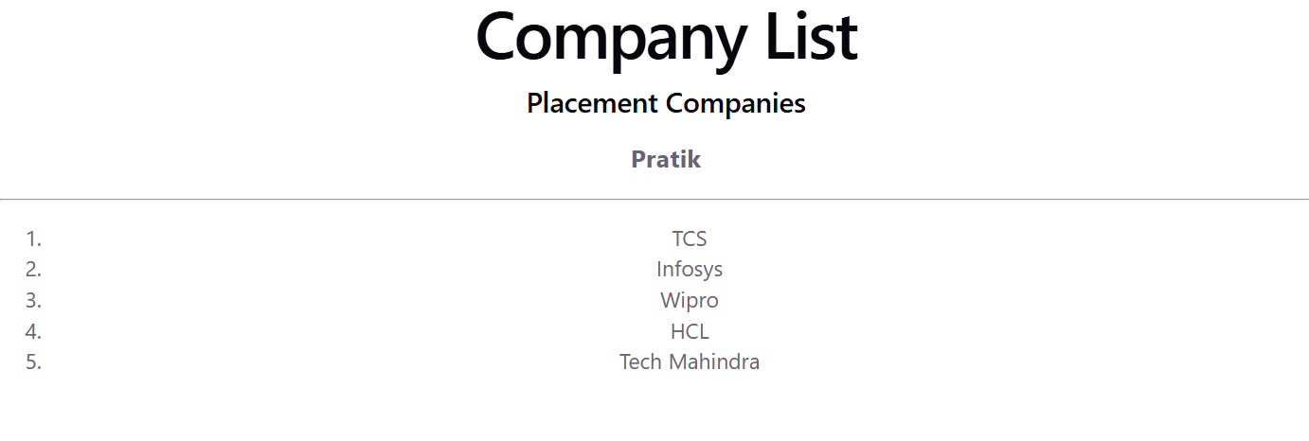
f. Build a small interactive component (e.g., counter or to-do list).
Code-:
import {useState} from 'react';
function App() {
const [count, setCount] = useState(0);
return (

<div className="App">

<h1>React Counter App</h1>
<h2>User Clicks : {count} times</h2>
<button onClick={() => setCount(count + 1)}>Increment</button>
<br/>
<button onClick={() => setCount(count - 1)}>Decrement</button>
<br/>
<button onClick={() => setCount(0)}>Reset</button>
<hr/>

<h3>Pratik</h3>
</div>
);
}

export default App;

Output-:
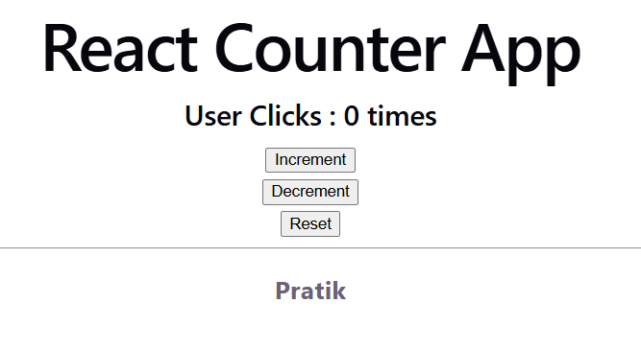
(To do list)
code-:
import { useState } from "react";
function App() {
const [task, setTask] = useState("");
const [tasks, setTasks] = useState([]);
// Add a new task
const addTask = () => {
if (task.trim() === "") {
alert("Please enter a task!");
return;
}
setTasks([...tasks, task]);
setTask("");
};
return (
<div style={{ textAlign: "center", marginTop: "30px" }}>
<h2>To-Do List</h2>
<input
type="text"
placeholder="Enter a task"
value={task}
onChange={(e) => setTask(e.target.value)}
/>
<button onClick={addTask} style={{ marginLeft: "10px" }}>
Add
</button>
<hr />
<h3>Task List</h3>
<ol>
{tasks.map((item, index) => (
<li key={index}>{item}</li>
))}
</ol>
</div>
);
}
export default App;
output-:
